Database ER Diagram & Data Dictionary
Inventory Audit Management System (IAMS)
Entity Relationships, Field-Level Schema, and Data Governance Notes
Document ID: IAMS-DD-1.0 | Version: 1.0 | Status: Draft for Review | Date: July 2026

Table of Contents

(Right-click and select “Update Field” in Word to populate this table after opening the document.)

Document Control

Purpose
This document defines the database schema for IAMS: entity-relationship diagrams grouped by functional cluster, and a field-level data dictionary for every entity. It is the schema-design gate flagged as a development blocker in prior review — backend persistence-layer code should not be written before this document is reviewed, since it fixes decisions (custom-field storage, immutability strategy, PII tagging) that are expensive to reverse once tables exist.
This document assumes the single-tenant-per-instance model confirmed in BRD Section 5.1: no tenant_id column is used anywhere in this schema. Multi-site scoping within one organization is handled entirely through org_node_id references into the recursive ORG_NODE hierarchy.
Version | Date | Author | Description
1.0 | 2026-07-06 | Product & Engineering | Initial ER diagrams (5 clusters) and full data dictionary covering all 16 FRS modules

1. Schema-Wide Conventions
- All primary keys are UUIDs, not auto-incrementing integers, to avoid leaking record counts and to simplify future multi-instance data merges (e.g., district-level roll-ups) without key collisions.
- Every entity has created_at; entities modifiable after creation also have updated_at, created_by, and updated_by (SRS Section 4.1).
- Fields tagged “append_only” belong to entities that are never updated or deleted in place — corrections are new rows referencing the original (FR-AUD-18, FR-CMP-06 legal hold).
- Fields tagged “PII” are flagged at the schema level so the anonymization engine (FR-CMP-02) and retention policy engine (FR-CMP-01) can operate generically without per-table hardcoded logic.
- Asset and Audit records use an integer version column for optimistic locking (NFR-CONC-01), incremented on every update; a write with a stale version is rejected rather than silently overwriting a concurrent edit.
- File attachments (asset photos, audit evidence) store only an object-store key (MinIO reference); binary content never lives in PostgreSQL (SRS Section 4.2).
- Custom fields (FR-AST-06) use a JSONB column validated against a per-category JSON Schema stored in asset_category.custom_field_schema, avoiding a migration per organization's field configuration.

2. Organization, Users & Roles
The root dependency cluster: every other entity ultimately scopes to a node in this hierarchy or a user in this table.
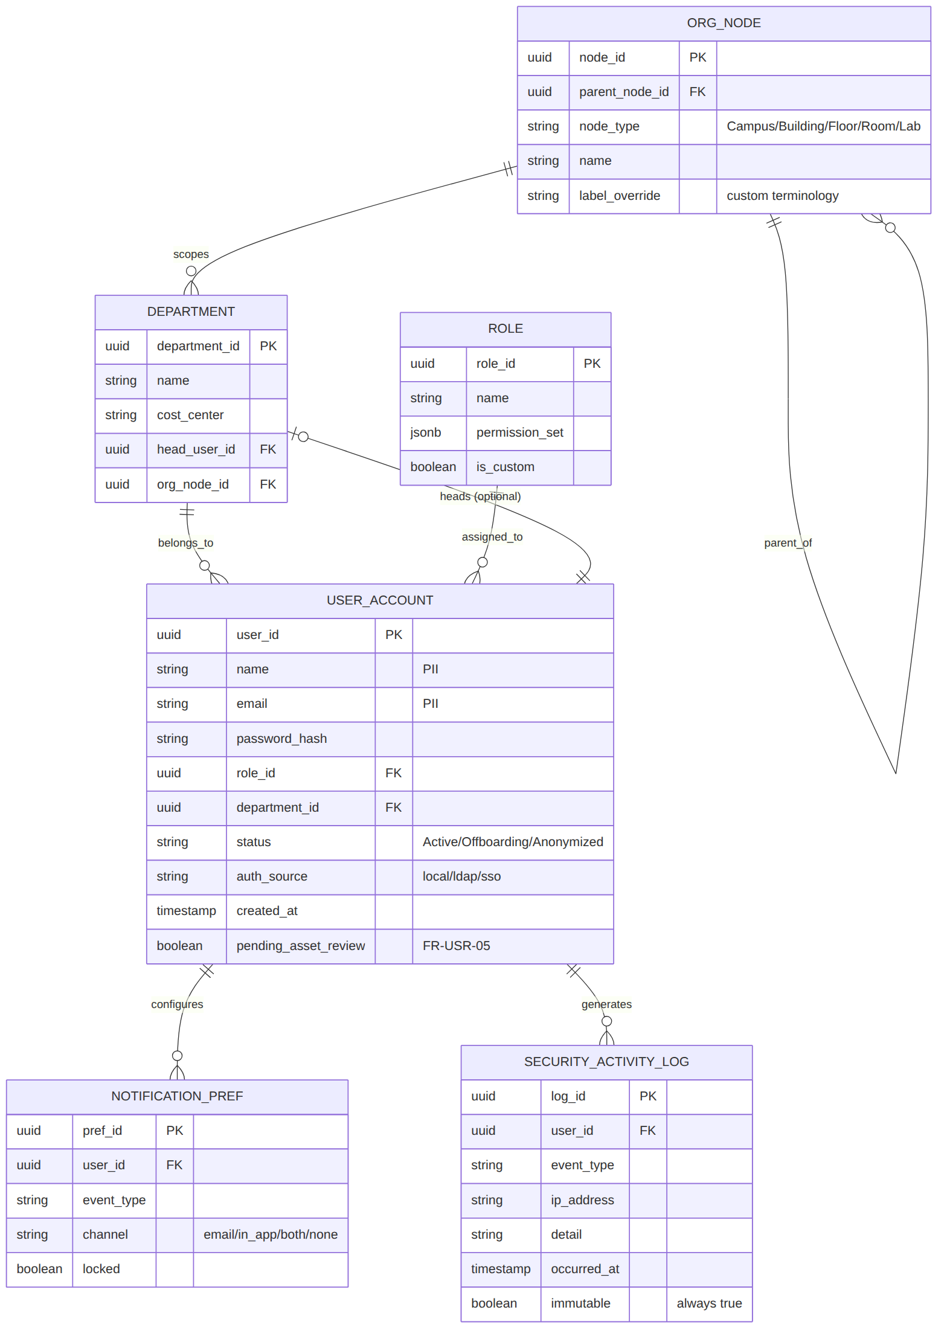

org_node
Recursive tree; supports Campus/Building/Floor/Room or Ministry/Department labeling via label_override (FR-ORG-02).
Field | Type | Constraint | Notes
node_id | UUID | PK | Unique node identifier
parent_node_id | UUID | FK → org_node.node_id, nullable | Null for the root (e.g., top-level Campus)
node_type | VARCHAR(30) | NOT NULL | Campus / Building / Floor / Room / Laboratory / Classroom
name | VARCHAR(120) | NOT NULL | Display name
label_override | VARCHAR(30) | nullable | Organization-specific term for node_type, e.g. “Parish”

department
Cost-center entity, independent of physical location (FR-ORG-03).
Field | Type | Constraint | Notes
department_id | UUID | PK
name | VARCHAR(120) | NOT NULL
cost_center | VARCHAR(30) | nullable
head_user_id | UUID | FK → user_account.user_id, nullable | Department Head persona
org_node_id | UUID | FK → org_node.node_id, nullable | Optional physical-site scoping

role
Default roles per FR-USR-01; custom roles supported per FR-USR-02.
Field | Type | Constraint | Notes
role_id | UUID | PK
name | VARCHAR(60) | NOT NULL, UNIQUE
permission_set | JSONB | NOT NULL | Structured permission grants, evaluated with org-scope (FR-USR-04)
is_custom | BOOLEAN | NOT NULL DEFAULT false

user_account
name and email are PII — subject to the anonymization workflow (FR-CMP-02) on offboarding.
Field | Type | Constraint | Notes
user_id | UUID | PK
name | VARCHAR(120) | NOT NULL — PII
email | VARCHAR(255) | NOT NULL, UNIQUE — PII
password_hash | VARCHAR(255) | nullable | Null when auth_source is ldap/sso
role_id | UUID | FK → role.role_id, NOT NULL
department_id | UUID | FK → department.department_id, NOT NULL
status | VARCHAR(20) | NOT NULL | Active / Offboarding / Anonymized
auth_source | VARCHAR(10) | NOT NULL | local / ldap / sso
pending_asset_review | BOOLEAN | NOT NULL DEFAULT false | Set true on deactivation attempt while assets remain assigned (FR-USR-05)
created_at | TIMESTAMP | NOT NULL

notification_pref
Per-user, per-event-type channel preference (FR-NTF-05).
Field | Type | Constraint | Notes
pref_id | UUID | PK
user_id | UUID | FK → user_account.user_id
event_type | VARCHAR(40) | NOT NULL
channel | VARCHAR(10) | NOT NULL | email / in_app / both / none
locked | BOOLEAN | NOT NULL DEFAULT false | True for Administrator-mandated notifications (e.g., security alerts)

security_activity_log
Append-only; never updated or deleted (FR-SEC-04, NFR-OBS-03 correlation).
Field | Type | Constraint | Notes
log_id | UUID | PK
user_id | UUID | FK → user_account.user_id, nullable | Null for failed logins with unrecognized username
event_type | VARCHAR(40) | NOT NULL | login_success / login_failed / permission_change / export / ...
ip_address | VARCHAR(45) | nullable
detail | TEXT | nullable
occurred_at | TIMESTAMP | NOT NULL

3. Asset Management & Lifecycle
The largest cluster by entity count, covering registration (FR-AST), procurement and lifecycle transitions (FR-LIF).
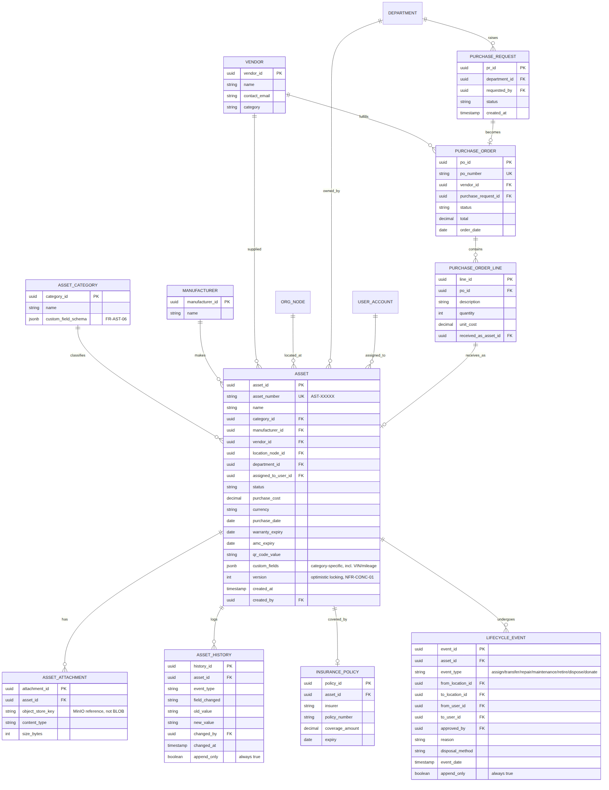

asset_category
Field | Type | Constraint | Notes
category_id | UUID | PK
name | VARCHAR(80) | NOT NULL, UNIQUE
custom_field_schema | JSONB | NOT NULL | JSON Schema validating asset.custom_fields for this category

asset
The central entity. version supports optimistic locking (NFR-CONC-01); custom_fields covers category-specific attributes including Vehicle VIN/mileage (FR-AST-14).
Field | Type | Constraint | Notes
asset_id | UUID | PK
asset_number | VARCHAR(20) | UNIQUE, NOT NULL | Human-facing ID, e.g. AST-00482
name | VARCHAR(160) | NOT NULL
category_id | UUID | FK → asset_category.category_id
manufacturer_id | UUID | FK → manufacturer.manufacturer_id, nullable
vendor_id | UUID | FK → vendor.vendor_id, nullable
location_node_id | UUID | FK → org_node.node_id
department_id | UUID | FK → department.department_id
assigned_to_user_id | UUID | FK → user_account.user_id, nullable
status | VARCHAR(20) | NOT NULL | In Use / In Storage / Under Repair / Missing / Retired / Disposed
purchase_cost | DECIMAL(12,2) | nullable
currency | CHAR(3) | NOT NULL DEFAULT 'USD' | FR-INV-06 multi-currency
purchase_date | DATE | nullable
warranty_expiry | DATE | nullable
amc_expiry | DATE | nullable
qr_code_value | VARCHAR(64) | UNIQUE | FR-SCN-07
custom_fields | JSONB | nullable | Validated against asset_category.custom_field_schema
version | INTEGER | NOT NULL DEFAULT 0 | Optimistic locking
created_at / created_by | TIMESTAMP / UUID | NOT NULL

asset_attachment
Field | Type | Constraint | Notes
attachment_id | UUID | PK
asset_id | UUID | FK → asset.asset_id
object_store_key | VARCHAR(255) | NOT NULL | MinIO reference (SRS Section 4.2)
content_type | VARCHAR(60) | NOT NULL
size_bytes | BIGINT | NOT NULL

asset_history
Append-only (FR-AST-10).
Field | Type | Constraint | Notes
history_id | UUID | PK
asset_id | UUID | FK → asset.asset_id
event_type | VARCHAR(40) | NOT NULL
field_changed / old_value / new_value | VARCHAR | nullable
changed_by | UUID | FK → user_account.user_id
changed_at | TIMESTAMP | NOT NULL

insurance_policy
FR-AST-13.
Field | Type | Constraint | Notes
policy_id | UUID | PK
asset_id | UUID | FK → asset.asset_id
insurer | VARCHAR(120) | NOT NULL
policy_number | VARCHAR(60) | NOT NULL
coverage_amount | DECIMAL(12,2) | nullable
expiry | DATE | nullable

manufacturer / vendor
Simple reference tables.
Field | Type | Constraint | Notes
manufacturer_id / vendor_id | UUID | PK
name | VARCHAR(120) | NOT NULL
contact_email (vendor only) | VARCHAR(255) | nullable
category (vendor only) | VARCHAR(60) | nullable

purchase_request / purchase_order / purchase_order_line
FR-LIF-01, 02, 03.
Field | Type | Constraint | Notes
pr_id / po_id / line_id | UUID | PK
department_id (PR) | UUID | FK → department.department_id
vendor_id (PO) | UUID | FK → vendor.vendor_id
purchase_request_id (PO) | UUID | FK → purchase_request.pr_id, nullable
status | VARCHAR(20) | NOT NULL
po_id (line) | UUID | FK → purchase_order.po_id
received_as_asset_id (line) | UUID | FK → asset.asset_id, nullable | Set once received (FR-LIF-03)

lifecycle_event
Append-only (FR-LIF-10). Covers assign/transfer/repair/maintenance/retire/dispose/donate.
Field | Type | Constraint | Notes
event_id | UUID | PK
asset_id | UUID | FK → asset.asset_id
event_type | VARCHAR(20) | NOT NULL | assign / transfer / repair / maintenance / retire / dispose / donate
from_location_id / to_location_id | UUID | FK → org_node.node_id, nullable
from_user_id / to_user_id | UUID | FK → user_account.user_id, nullable
approved_by | UUID | FK → user_account.user_id, nullable | Required for transfer/disposal per separation of duties
disposal_method | VARCHAR(60) | nullable | e.g., e-waste compliant (FR-LIF-09)
event_date | TIMESTAMP | NOT NULL

4. Inventory Management
Quantity-based consumables and spare parts, distinct from individually tracked assets (FR-INV).
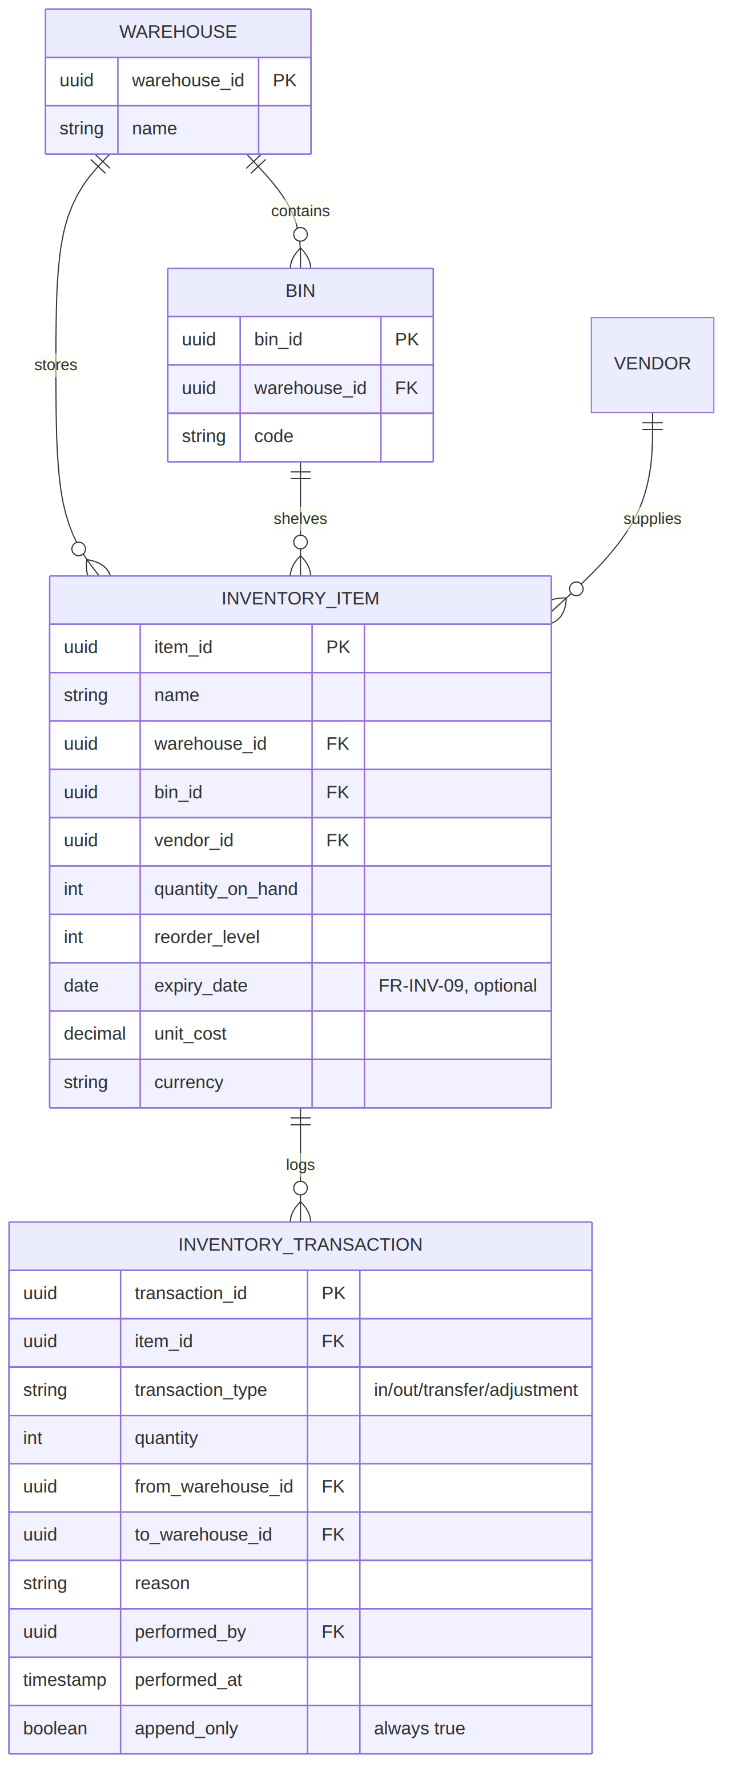

warehouse / bin
Field | Type | Constraint | Notes
warehouse_id / bin_id | UUID | PK
warehouse_id (bin) | UUID | FK → warehouse.warehouse_id
name / code | VARCHAR(80) | NOT NULL

inventory_item
expiry_date supports FR-INV-09 (lab chemicals, perishables).
Field | Type | Constraint | Notes
item_id | UUID | PK
name | VARCHAR(160) | NOT NULL
warehouse_id / bin_id | UUID | FK, NOT NULL / nullable
vendor_id | UUID | FK → vendor.vendor_id, nullable
quantity_on_hand | INTEGER | NOT NULL DEFAULT 0
reorder_level | INTEGER | NOT NULL DEFAULT 0
expiry_date | DATE | nullable
unit_cost / currency | DECIMAL / CHAR(3) | nullable | FR-INV-06

inventory_transaction
Append-only. transfer_type distinguishes a linked transfer pair from independent in/out (FR-INV-08).
Field | Type | Constraint | Notes
transaction_id | UUID | PK
item_id | UUID | FK → inventory_item.item_id
transaction_type | VARCHAR(15) | NOT NULL | in / out / transfer / adjustment
quantity | INTEGER | NOT NULL
from_warehouse_id / to_warehouse_id | UUID | FK, nullable | Both set for transfer type
reason | VARCHAR(120) | nullable | Required for adjustment type
performed_by | UUID | FK → user_account.user_id
performed_at | TIMESTAMP | NOT NULL

5. Audit Management — Core Differentiator
The schema for the module the BRD names as the primary differentiator; immutability and reconciliation are enforced structurally, not just procedurally.
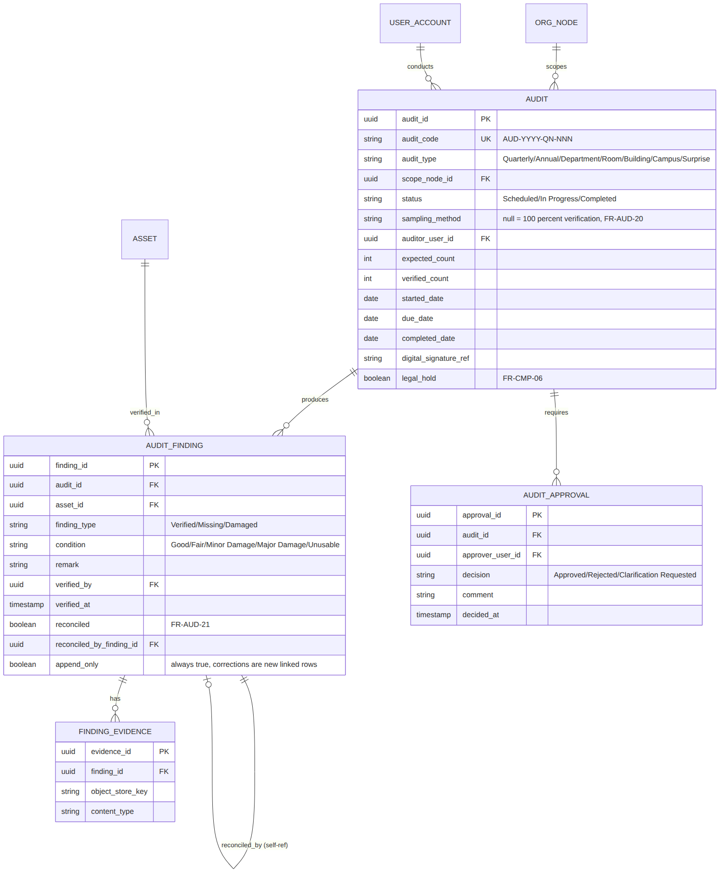

audit
sampling_method null means 100% verification; non-null means statistical sampling at scale (FR-AUD-20).
Field | Type | Constraint | Notes
audit_id | UUID | PK
audit_code | VARCHAR(24) | UNIQUE, NOT NULL | e.g. AUD-2026-Q3-014
audit_type | VARCHAR(20) | NOT NULL | Quarterly/Annual/Department/Room/Building/Campus/Surprise
scope_node_id | UUID | FK → org_node.node_id
status | VARCHAR(15) | NOT NULL | Scheduled / In Progress / Completed
sampling_method | VARCHAR(40) | nullable | FR-AUD-20
auditor_user_id | UUID | FK → user_account.user_id
expected_count / verified_count | INTEGER | nullable / NOT NULL DEFAULT 0
digital_signature_ref | VARCHAR(255) | nullable | FR-AUD-12
legal_hold | BOOLEAN | NOT NULL DEFAULT false | FR-CMP-06; blocks retention-policy purge

audit_finding
Append-only (FR-AUD-18). reconciled_by_finding_id links a later reconciliation (FR-AUD-21) back to the original Missing finding without editing it.
Field | Type | Constraint | Notes
finding_id | UUID | PK
audit_id | UUID | FK → audit.audit_id
asset_id | UUID | FK → asset.asset_id
finding_type | VARCHAR(15) | NOT NULL | Verified / Missing / Damaged
condition | VARCHAR(20) | nullable | Good/Fair/Minor Damage/Major Damage/Unusable (FR-AUD-09)
remark | TEXT | nullable
verified_by / verified_at | UUID / TIMESTAMP | NOT NULL
reconciled | BOOLEAN | NOT NULL DEFAULT false
reconciled_by_finding_id | UUID | FK → audit_finding.finding_id, nullable

finding_evidence
FR-AUD-10.
Field | Type | Constraint | Notes
evidence_id | UUID | PK
finding_id | UUID | FK → audit_finding.finding_id
object_store_key | VARCHAR(255) | NOT NULL
content_type | VARCHAR(60) | NOT NULL

audit_approval
FR-AUD-13.
Field | Type | Constraint | Notes
approval_id | UUID | PK
audit_id | UUID | FK → audit.audit_id
approver_user_id | UUID | FK → user_account.user_id
decision | VARCHAR(25) | NOT NULL | Approved / Rejected / Clarification Requested
comment | TEXT | nullable
decided_at | TIMESTAMP | NOT NULL

6. Compliance, Security & Integrations
Supports the CMP, SEC, INT, MIG, and ANL modules — the cluster added specifically to close the compliance and integration-security gaps from the adversarial review.
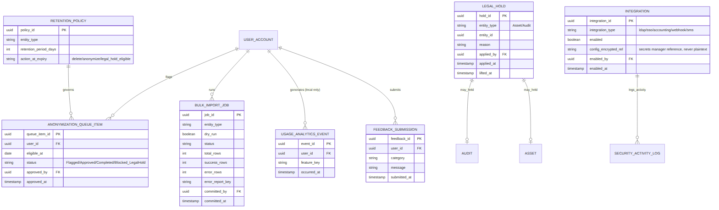

retention_policy
FR-CMP-01.
Field | Type | Constraint | Notes
policy_id | UUID | PK
entity_type | VARCHAR(40) | NOT NULL | e.g. security_activity_log, user_account
retention_period_days | INTEGER | NOT NULL
action_at_expiry | VARCHAR(20) | NOT NULL | delete / anonymize / legal_hold_eligible

anonymization_queue_item
FR-CMP-02.
Field | Type | Constraint | Notes
queue_item_id | UUID | PK
user_id | UUID | FK → user_account.user_id
eligible_at | DATE | NOT NULL
status | VARCHAR(25) | NOT NULL | Flagged / Approved / Completed / Blocked_LegalHold
approved_by / approved_at | UUID / TIMESTAMP | nullable | Compliance Officer approval

legal_hold
FR-CMP-06. entity_id is polymorphic (references asset.asset_id or audit.audit_id depending on entity_type).
Field | Type | Constraint | Notes
hold_id | UUID | PK
entity_type | VARCHAR(10) | NOT NULL | Asset / Audit
entity_id | UUID | NOT NULL | Polymorphic reference
reason | TEXT | NOT NULL
applied_by / applied_at | UUID / TIMESTAMP | NOT NULL
lifted_at | TIMESTAMP | nullable

integration
FR-INT-05: disabled by default. config_encrypted_ref never stores plaintext credentials (FR-SEC-11).
Field | Type | Constraint | Notes
integration_id | UUID | PK
integration_type | VARCHAR(20) | NOT NULL | ldap / sso / accounting / webhook / sms
enabled | BOOLEAN | NOT NULL DEFAULT false
config_encrypted_ref | VARCHAR(255) | nullable | Secrets-manager reference, not plaintext
enabled_by / enabled_at | UUID / TIMESTAMP | nullable

bulk_import_job
FR-MIG-01–04.
Field | Type | Constraint | Notes
job_id | UUID | PK
entity_type | VARCHAR(40) | NOT NULL
dry_run | BOOLEAN | NOT NULL
status | VARCHAR(20) | NOT NULL
total_rows / success_rows / error_rows | INTEGER | NOT NULL DEFAULT 0
error_report_key | VARCHAR(255) | nullable | Object-store reference to per-row error report
committed_by / committed_at | UUID / TIMESTAMP | nullable

usage_analytics_event / feedback_submission
FR-ANL-01–04. Local only — never transmitted outside the deployment (FR-ANL-02).
Field | Type | Constraint | Notes
event_id / feedback_id | UUID | PK
user_id | UUID | FK → user_account.user_id
feature_key (event) | VARCHAR(60) | NOT NULL
category / message (feedback) | VARCHAR / TEXT | NOT NULL
occurred_at / submitted_at | TIMESTAMP | NOT NULL

7. Open Design Decisions for Engineering Review
These are the specific decisions this schema makes that engineering should confirm before writing migrations, since they are the ones most expensive to reverse:
- JSONB for custom_fields and permission_set assumes PostgreSQL; if a different database were ever substituted (SRS Section 8 fixes PostgreSQL, so this should not occur, but is noted for completeness), this would need redesign.
- Polymorphic entity_id on legal_hold (no formal foreign key constraint) trades referential-integrity enforcement for avoiding a hold table per entity type; engineering should confirm this tradeoff or add application-level integrity checks.
- Optimistic locking (version column) is specified only on asset and, implicitly, should extend to audit and audit_finding given their concurrent-edit risk during live audits — confirm during migration design.
- Full-text/global search (FR-SRC-01) is not modeled as a separate entity here; it is expected to be implemented via PostgreSQL full-text search or a search index over existing tables, not a new persisted entity.

